Computer networks

**Lab activity – 3**

**Name :** N.V.M.Sumanth

**Reg no :** 192111449

**Faculty :** Dr. S. Ramesh

**Course code :** CSA0786 computer networks for wanet applications

**Lab activity : 3**

**Question : Data Link Layer Traffic Simulation using Packet Tracer Analysis of CSMA/CD & CSMA/CA.**

**Step 1 : Take a hub.**

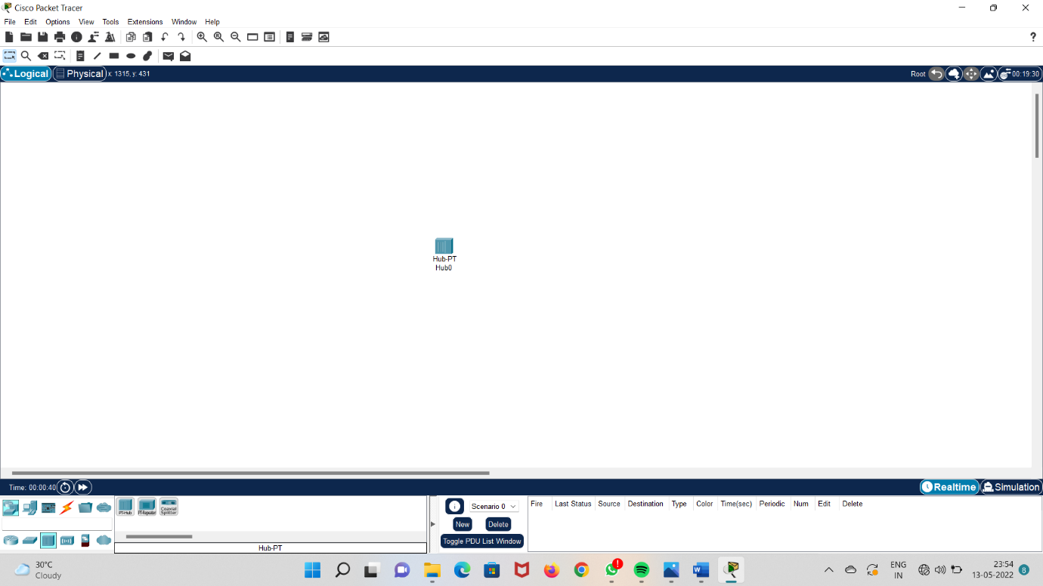

**Step 2 : Take six computers and place them in a circular way**

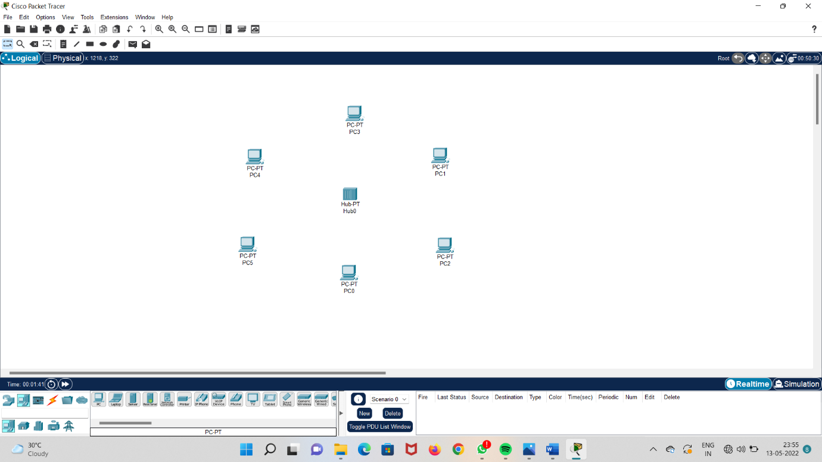

**Step 3 : Connect all the computers to the hub.**

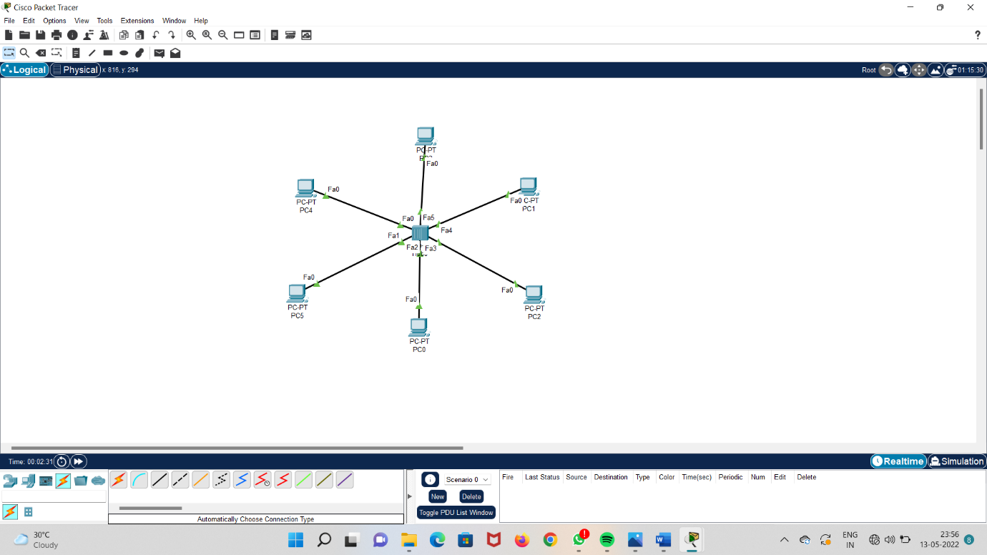

**Step 4 : add IP addresses to the computers.**

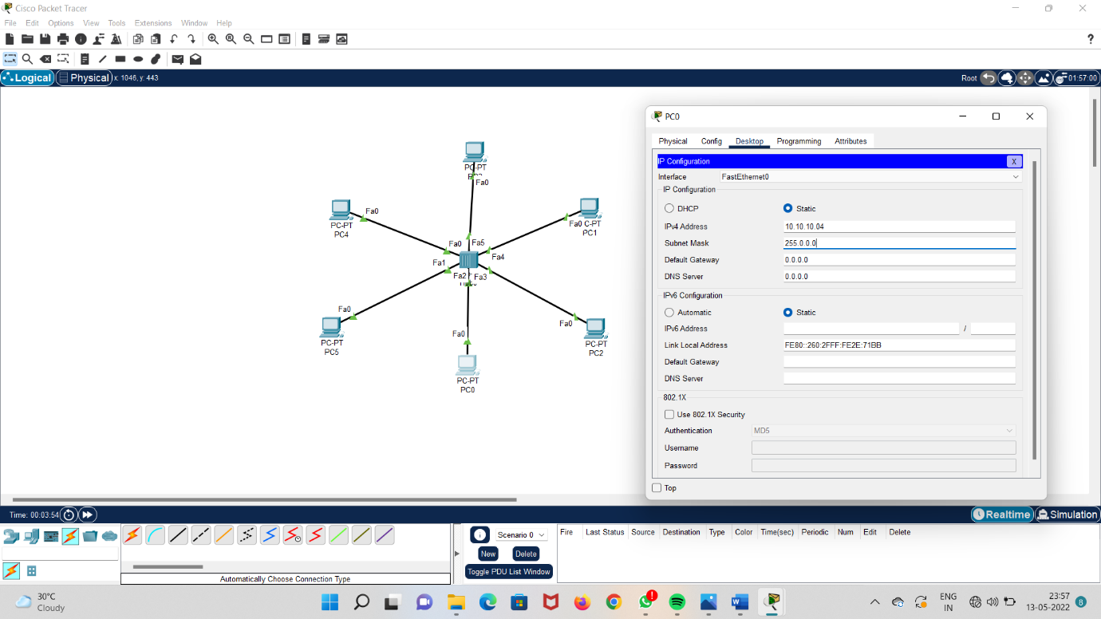

**Step 5 : run the system and check acknowledgement.**

